Proof of Principle Fund | Grant application form
Revision: V03
Date: 22 May 2017

Project title
Applicant
Location

Application version

Application date

Writing guide for Proof of Principle (PoP) application

This document provides additional information, background, comments, and suggestions that can be useful when completing an LBDF PoP application.

Version 2 / September 2017 / Jorg van der Meij

Contents
Contents 2
Introduction 3
Management summary 4
1 Applicant details 5
2 Financial details 6
3 Innovation project 7
4 Feasibility study 11
5 Signature 15
Appendix 1 SME declaration 16

Structure of application
The structure of a PoP application is as follows:

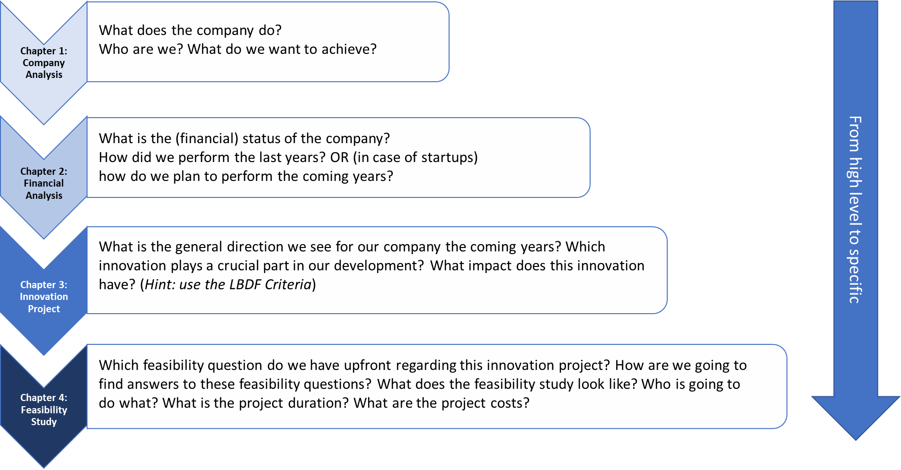

General remarks and tips (open sessions are sometimes available):
- Check for any spelling errors
- Do not change the format and headings (however, fonts and layout may be changed).
- Answer all questions in the form (a completeness check is performed in advance).
- You may submit your application in English, provided that you do not change the original headings.
- Write the application in the third person, speaking as the company: not ‘We're going to XYZ’, but ‘[Company name] is going to XYZ.’
- Use pictures! Make sure you have a good description of the pictures.
- Try to be as specific as possible and to underpin everything with figures and sources, avoiding generalizations such as ‘the market potential is huge.’

Introduction
Please note that the following rules apply to this application:
- This document is intended for persons who wish to apply for a grant from the Proof of Principle (PoP) Fund, provided by the Limburg Business Development Fund (LBDF).
- The sole aim of the Limburg Business Development Fund is to boost competitiveness and strengthen support structures for businesses in Limburg.
- Grants from the PoP Fund are exclusively intended to be used to carry out research into the technical, economic, and commercial feasibility of a new product, service, or technology to be developed. The results of the research must also be incorporated into an overall plan, describing how the new product/market combination will be transformed into a business activity.
- Applications may be submitted electronically at www.liof-lbdf.nl.
Once you have submitted your application, you will receive confirmation immediately.
- Only complete applications will be considered. An application is deemed to be complete if all fields have been filled in, and the application form and SME declaration have been signed by an authorized person. If your application is complete, you will receive confirmation of receipt. If your application is not complete, you will be informed of this.
- If your application is admissible, it will be assessed by the LBDF. The grant you have requested will then be approved or declined following assessment. The applicant will be informed of the LBDF’s decision.
Definitions
Feasibility study: The part of the innovation project required to determine the technical, economic or commercial feasibility of a new product, service, or technology to be developed.

Management summary
Please provide a concise summary of your innovation project, including a clear description of the reason or problem, its objective(s), its innovative nature, its market prospects, and its economic impact.

Applicant details

1.1. Your business
Name of business
 |  | If different
Business address |  | Postal address
Postcode |  | Postcode
Town/city |  | Town/city
Chamber of Commerce number |  | Place of incorporation
Legal form |  | SBI code

Business sector(s) | ☐ Agri / Food
 | ☐ Chemicals / Materials
 | ☐ Finance / Administration
 | ☐ High-tech Systems
 | ☐ Life Sciences
 | ☐ Logistics
☐ Manufacturing
☐ More than one of these sectors

1.2 Contact details
Title | ☐ Mr ☐ Ms
Surname |  | Initial(s)
Position
Telephone
Email

1.3 Your profile
Please provide a description of the entrepreneur(s), the business, and how it has developed. Describe the structure of the business and specify any affiliated legal entities (e.g. shareholders, affiliates, subsidiaries, and holdings) in an organization chart. Also state the percentage of affiliation of such legal entities.

1.4 Business analysis
Describe your current situation: key products/services and processes, business models, market, customers, and competition. Also provide figures for the scope or size.

Financial details

2.1 Your financial details
In the table below, please provide your financial details over the last three financial years and a forecast for the ongoing or next financial year. This table will be considered when assessing your enterprise.

Financial year |  |  |  | Current financial year
No. of employees
BALANCE SHEET
Intangible fixed assets
Tangible fixed assets
Current assets
Total assets
Equity
Subordinated loans
Reserves
Long-term loans
Short-term loans
Total liabilities
PROFIT AND LOSS
Turnover
Purchase value
Gross profit
Staff costs
Other operational costs
Write-offs
EBIT
Interest
Extraordinary income and expenditure
Tax
Net profit
Investments

Explanation
You must provide an explanation of any financial details that could be relevant to the grant application and assessment.

Innovation project
The description of the innovation project is crucial.

Here are some tips:
- Try to be consistent. For instance, address the problems you stated in 3.1 again in 3.3, or mention the objectives described in 3.2 again in chapter 4.
- Use bullet points to create a list. For instance, you could first make a bullet-point list and then provide more information alongside each point.

Writing aids:
- A simple writing aid for describing a problem is the Value Diamond. The Need/Problem and Reference can be used to structure the ‘Problem’ (3.1). Solution and Benefits can be used as a guideline to describe the ‘Innovative nature’ under 3.3.

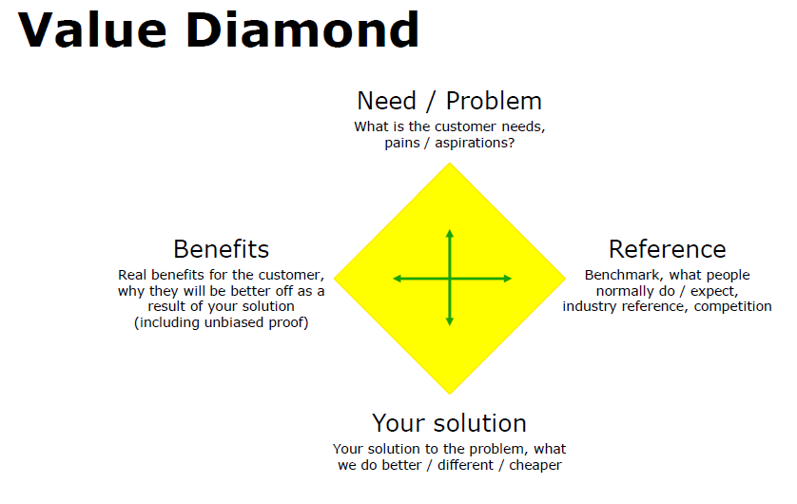

- In addition, you could also use and discuss the business model canvas (link to video and canvas) and the value proposition canvas (link to video and canvas).

3.1 Problem
Describe the problem or reason behind the project, from both the intended market/customer perspective and your business’s perspective if applicable.

3.2 Objective(s)
Describe the objective(s), intended development(s), and results of this project, in line with the SMART principle (Specific, Measurable, Achievable, Realistic, and Time-bound).

Tips:
Use the research questions, and the sub-questions can be used as a guideline in chapter 4.

Suggestion
The aim of this project is to investigate the feasibility of developing product x that meets the specific requirements of market y.

The main question in this feasibility study is whether it is technically, commercially, organizationally, and ... feasible to develop product x .

To answer this question, three sub-questions have been identified:
- What are the technical challenges and risks associated with developing product x and how does company z deal with these?
- Is there a market demand for product x? Which specifications are applicable to the product and what is the product's target price level?
- …

Based on these questions, company z tries to gain a good overview of the risks, challenges, and possibilities, so that it has a sound idea of the product's or project's feasibility.

Tips:
If there are specific risks associated with the project, consider adding a risk analysis. Identify the risk and indicate its impact on the development of the project: what is its effect and what measures can be implemented to minimize this risk?

Suggestion for risk analysis:
The major risks associated with developing ... could be set out as follows:
Risk:
Explanation:
Effect:
Measure:

Risk 2:
Etc.

3.3 Innovative nature
Describe the innovative nature of the project, including the added value in relation to existing or current products, processes, services, or developments; state the degree of maturity of the technology used. Mention how any intellectual property will be protected, if applicable.

Without a competitive advantage over alternatives, you have no value proposition.

Suggestion (in addition to the described elements)

Add a table comparing the alternatives with your innovative product.
Where relevant, add a technical or other picture to support the innovative part of the development.

3.4 Market perspective
Describe the market perspective of the project, including the customers/customer segments, geographical scope, market size in the target area (turnover/figures) and forecast for the next five years, intended market share (including reasoning) and forecast for the next five years, sales/distribution channels, and IP rights.
Suggestion (in addition to the described elements)

- Describe the target market and possible target groups within that market. If you start with a specific market, explain why. Describe the characteristics of this market.
- Indicate whether geographical choices are made and why. Provide a description of the specific characteristics of these geographical markets.
- You can use the DESTEP or PESTLE analysis as an aid.

3.5 Economic impact
Describe the economic impact of the project on the business, including the business model, the proposed purchase price, gross margin, and turnover for the next five years, the expected return on investment (including reasoning), the impact on internal/external employment opportunities, and competitiveness.

Suggestion (in addition to the described elements)

- Support this section with relevant figures and sources.
- For clarity's sake, present the expected revenues in table form.
- Describe the connection with and impact on the region.

Feasibility study

4.1 Project plan
Provide an overall description of the plan for the entire innovation project, including activities, partial and overall results, milestones, schedule, and any partners involved.

Suggestion (in addition to the described elements)

- Use bullet points to create a list.

Example

The project as a whole consists of the following phases:
- Feasibility study
- Proof of concept
- Go to market
- Growth phase

Re 1 Feasibility study
This phase is described in section 4.2.

Re 2 Proof of concept
This phase will start with the results of the feasibility study.
If the results are positive, then at this stage we will ...

Etc.

Tip: In the growth phase, indicate which growth strategies are used (e.g. using Ansoff).

4.2 Feasibility study
Provide a detailed description of the feasibility study that you will be undertaking with the grant, including activities, partial and overall results, milestones, schedule, and any partners involved.
Suggestion (in addition to the described elements)

- In this section, it’s important to demonstrate that the plan of action will lead to an answer to the questions (justification of the hours and costs in advance). Try to be as specific as possible.
- Use bullet points and tables to create a list.

Example

The feasibility study consists of the following phases (consistent with objective under 3.2):
- Technical feasibility
- Economic feasibility
- Organizational feasibility
- …

Re 1 Technical feasibility
First provide a textual description: ‘The first question that needs to be answered: (question from 3.2):...’.

Technical feasibility
Timing: from … to … inclusive
Aim: Investigating the technical feasibility...
Description of activities:
- Activity 1
- Activity 2
- …
Partial results:
- Result 1
- Result 2
- …
Costs (consistent with cost budget 4.4):
- Staff costs
- Material costs

Re 2 Economic feasibility
…

Etc.

4.3 Schedule
Specify the scheduled start date and duration (in months) of the feasibility study. The feasibility study must be completed within 12 months of the grant decision date, but no later than by 1 April 2022.

The feasibility study will start on
The feasibility study will last for months.
Suggestion (in addition to the described elements)

- Use a picture or table to show the various phases of the project according to the times at which they take place. This makes it clear whether things are parallel or sequential.

4.4 Cost budget
In the table below, specify the anticipated costs that you have budgeted for and the amount of financing for the feasibility study per cost type.
Note: all costs should exclude VAT.
Cost type | Cost amount  [€] |  | Finance source | Percentage  [%] | Amount  [€]
Staffing |  |  | Personal contribution
Materials |  |  | LBDF grant
Equipment
Other
Total
WBSO grant | -/-
Other income/grants | -/-
Total eligible costs |  |  | Total financing | 100%

Explanation of the cost budget
You must provide an explanation of the cost budget and details of each cost type.

Signature
Suggestion (in addition to the described elements)

- Try to add an explanation for each cost type.

Example

Staff costs
The staff costs are shown in the table below.

Name | € per hour | Total number of hours | Staff costs
Person A | € 60 | 100 | € 6000
Person B | € 60 | 100 | € 6000
Total |  |  | € 12000

Material costs
The cost of materials is estimated at €1000. The costs are based on...

Etc.

By signing this application, you as the undersigned applicant declare the following:
- You are authorized to sign and submit the application.
- All details you have provided are true.
- You are responsible and liable for ensuring activities forming part of this feasibility study are carried out properly and for complying with the terms and conditions and obligations associated with the PoP Fund.
- You have read the Proof of Principle Fund grant regulations applicable at the time of signing this grant application (see www.liof-lbdf.nl).
- You will cooperate with the assessment of the impact of your innovation project on request.
- You will cooperate with LBDF publications and PR activities on request.
- This project as described in this application has not already started prior to submitting this application to LBDF.
- You act as guarantor for your own financial contribution towards this project.
- All alternative financing and grant options have been explored and exhausted.
- Any suppliers whose costs you have claimed as eligible costs are not a parent company, subsidiary, or affiliate, as defined in company law, and there is no family relationship with any such suppliers.
- You have not been suspended from trading or declared bankrupt.
- You comply with the standards under the Bibob (Public Administration (Probity Screening) Act) and/or integrity policy for the Province of Limburg if the legislation does not apply.
- You comply with the standards under the corporate social responsibility policy of the Province of Limburg.
- You are familiar with and comply with the rules on state aid for undertakings.
- Your company meets the European conditions for SME status (see Appendix 1).

Town/city | Date | Name | Position
Company stamp and logo |  | Signature

Appendix 1 SME declaration
According to 'Micro-, small- and medium-sized enterprises: definition and scope’, the European Commission defines a medium-sized enterprise as having fewer than 250 FTEs and a small enterprise as having fewer than 50. An enterprise must be independent and have limited annual turnover. The criteria above apply to a company as a whole, including any subsidiaries.
For more information, see the User guide to the SME Definition. This brochure contains clear examples of how the total figures for number of employees, turnover, and balance sheet total is calculated for an enterprise, including subsidiaries and affiliates. Please read this brochure carefully before providing the figures.
By signing this document under the ‘Signature’ section, the applicant declares that he/she has read and accepted the rules on the SME status for enterprises.
The applicant declares the following figures to be true for his/her enterprise, , in the previous financial year 20 :
Number of FTEs (< 250 people)
AND
Annual turnover (<€50m)
OR
Balance sheet total (<€43m)

